# *COMPUTATION OF LEADING AND TRAILING*

# *Ayush Jindal*

# *RA1911003010308*

***Aim:*** *To create a program that computes LEADING and TRAILING of given grammar.*

***Algorithm:***

*Step1: Start.*

*Step2: Get the no of production and calculate the length of each production.*

*Step3: With a variable val for checking the valid non terminals if they are duplicated get all Non terminals in an array.*

*Step4: In each production check the first accurate of terminals and take that terminal and add it to leading of non terminal in array and exit*

*the loop.*

*Step5: Scan the production and find the last terminal and add it to respective trailing array of associated non terminal &exit the loop.*

*Step6: Consider production with a non terminal on right side and check the leading of that non terminal associated production and also trailing*

*and add it to the leading and trailing of left side non terminal.*

*Step7: Write the leading and trailing terminals for each non terminal. Step8: Stop.*

## *Code:*

*#include <iostream> #include <cstring> using namespace std; int nt,t,top=0;*

*char s[50],NT[10],T[10],st[50],l[10][10],tr[50][50];*

*int searchnt(char a)*

*{*

*int count=-1,i; for(i=0;i<nt;i++)*

*{*

*if(NT[i]==a) return i;*

*}*

*return count;*

*}*

*int searchter(char a)*

*{*

*int count=-1,i; for(i=0;i<t;i++)*

*{*

*if(T[i]==a) return i;*

*}*

*return count;*

*}*

*void push(char a)*

*{*

*s[top]=a; top++;*

*}*

*char pop()*

*{*

*top--;*

*return s[top];*

*}*

*void installl(int a,int b)*

*{*

*if(l[a][b]=='f')*

*{*

*l[a][b]='t';*

*push(T[b]);*

*push(NT[a]);*

*}*

*}*

*void installt(int a,int b)*

*{*

*if(tr[a][b]=='f')*

*{*

*tr[a][b]='t';*

*push(T[b]);*

*push(NT[a]);*

*}*

*}*

*int main()*

*{*

*int i,s,k,j,n;*

*char pr[30][30],b,c;*

*cout<<"Enter the no of productions:"; cin>>n;*

*cout<<"Enter the productions one by one\n"; for(i=0;i<n;i++)*

*cin>>pr[i]; nt=0;*

*t=0;*

*for(i=0;i<n;i++)*

*{*

*if((searchnt(pr[i][0]))==-1) NT[nt++]=pr[i][0];*

*}*

*for(i=0;i<n;i++)*

*{*

*for(j=3;j<strlen(pr[i]);j++)*

*{*

*if(searchnt(pr[i][j])==-1)*

*{*

*if(searchter(pr[i][j])==-1)*

*T[t++]=pr[i][j];*

*}*

*}*

*}*

*for(i=0;i<nt;i++)*

*{*

*for(j=0;j<t;j++) l[i][j]='f';*

*}*

*for(i=0;i<nt;i++)*

*{*

*for(j=0;j<t;j++)*

*tr[i][j]='f';*

*}*

*for(i=0;i<nt;i++)*

*{*

*for(j=0;j<n;j++)*

*{*

*if(NT[(searchnt(pr[j][0]))]==NT[i])*

*{*

*if(searchter(pr[j][3])!=-1) installl(searchnt(pr[j][0]),searchter(pr[j][3])); else*

*{*

*for(k=3;k<strlen(pr[j]);k++)*

*{*

*if(searchnt(pr[j][k])==-1)*

*{*

*installl(searchnt(pr[j][0]),searchter(pr[j][k])); break;*

*}*

*}*

*}*

*}*

*}*

*}*

*while(top!=0)*

*{*

*b=pop();*

*c=pop(); for(s=0;s<n;s++)*

*{*

*if(pr[s][3]==b) installl(searchnt(pr[s][0]),searchter(c));*

*}*

*}*

*for(i=0;i<nt;i++)*

*{*

*cout<<"Leading["<<NT[i]<<"]"<<"\t{"; for(j=0;j<t;j++)*

*{*

*if(l[i][j]=='t')*

*cout<<T[j]<<",";*

*}*

*cout<<"}\n";*

*}*

*top=0; for(i=0;i<nt;i++)*

*{*

*for(j=0;j<n;j++)*

*{*

*if(NT[searchnt(pr[j][0])]==NT[i])*

*{*

*if(searchter(pr[j][strlen(pr[j])-1])!=-1)*

*installt(searchnt(pr[j][0]),searchter(pr[j][strlen(pr[j])-1]));*

*else*

*{*

*for(k=(strlen(pr[j])-1);k>=3;k--)*

*{*

*if(searchnt(pr[j][k])==-1)*

*{*

*installt(searchnt(pr[j][0]),searchter(pr[j][k])); break;*

*}*

*}*

*}*

*}*

*}*

*}*

*while(top!=0)*

*{*

*b=pop();*

*c=pop(); for(s=0;s<n;s++)*

*{*

*if(pr[s][3]==b) installt(searchnt(pr[s][0]),searchter(c));*

*}*

*}*

*for(i=0;i<nt;i++)*

*{*

*cout<<"Trailing["<<NT[i]<<"]"<<"\t{"; for(j=0;j<t;j++)*

*{*

*if(tr[i][j]=='t')*

*cout<<T[j]<<",";*

*}*

*cout<<"}\n";*

*}*

*}*

## *Output:*

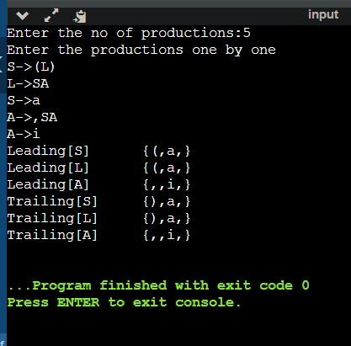

***Manual calculation:***

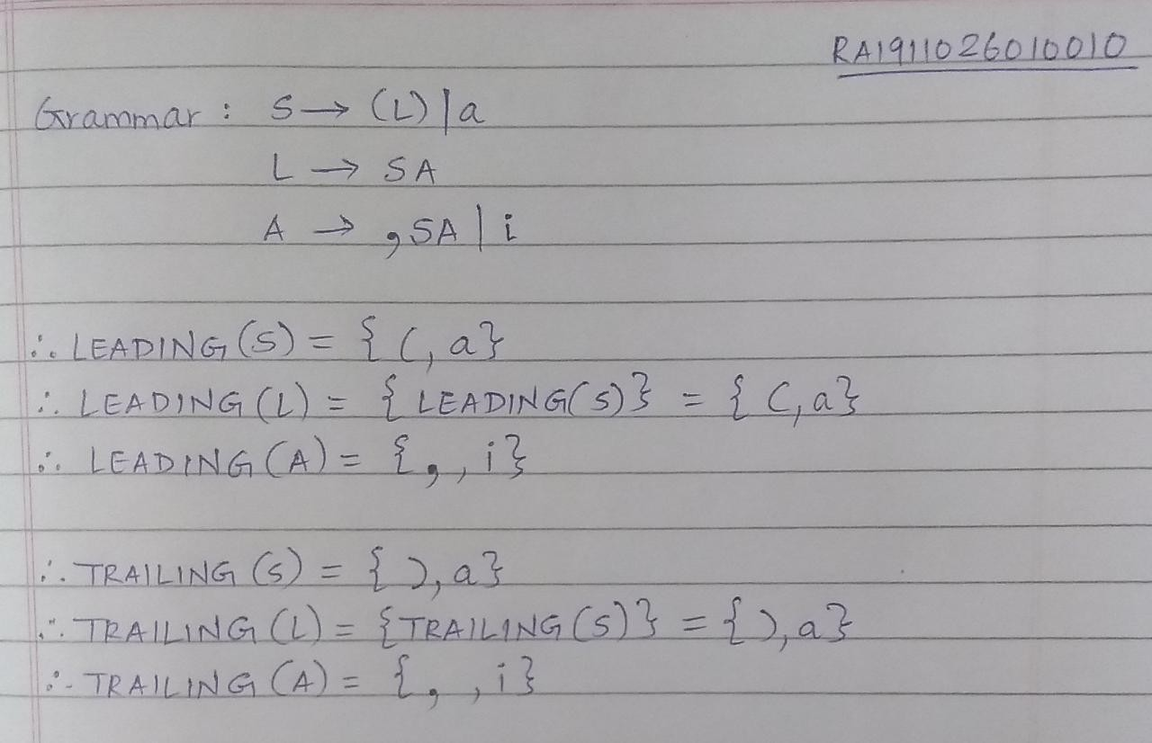

***Result:*** *Thus, we created a program that computes and displays the LEADING and TRAILING for given grammar*